Science 30 Course Outline
Mrs. Gare
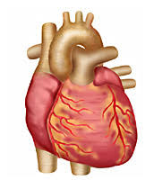
Room 122
doris.gare@wrps11.ca

Course content

Unit 1: Living Systems Respond to Their Environment
Key concepts: By the end of this unit you will understand the following
- structure and function of the circulatory system
- composition of human blood tissue and the role of blood
- immune response and defense mechanisms to pathogens
- cardiovascular health
- chromosomal behaviour
- principle of Mendelian genetics
- deoxyribonucleic acid DNA and protein synthesis
- mutations and gene therapy

Unit 2: Chemistry in the Environment
Key concepts: By the end of this unit you will understand the following
- acids and bases
- pH and hydronium ion concentration
- stoichiometry and titration of strong monoprotic acids and strong monotropic bases
- buffers and buffering capacity
- sources and environmental impact to SO_{x}, NO_{x}, acid deposition and photochemical smog
- sources, uses and environmental effects of organic compounds
- biomagnification and persistence of pollutants

Unit 3: Electromagnetic Energy
Key concepts: By the end of this unit you will understand the following
- devices based on electric and magnetic fields (electric motors, generators and transformers)
- the electromagnetic spectrum, its properties and its effects on living tissue
- basic properties of field theory for the comparison of gravitational, electric and magnetic fields
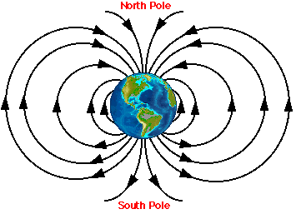
- principles of field theory and applications in technology
- technologies used to study the structure and history of the universe
- circuitry

Unit 4: Energy and the Environment
Key concepts: By the end of this unit you will understand the following
- global energy consumption and its impact on the biosphere
- sources of renewable energy
- balancing energy use with sustainable development
- conversion of solar energy, fossil fuels and wind and water power into thermal and electrical energy
- fission and fusion, nuclear change
- heat’s of formation and Hess’s law
- nuclear, wind, hydro, biomass, tidal, fuel cell and geothermal energy technologies
Approximate timeline

Unit 1 (Exam) September 4th to October 2nd 20 days

Unit 2 (Exam) October 3rd to November 2nd 20 days

Unit 3 (Exam) November 5th to December 3rd 18 days

Unit 4 (Exam) December 4th to January 11th 18 days

Review January 14th to January 22nd 7 days

Diploma Exam January 30th 1:00PM - 4:00PM

→Please note that these dates are just approximate and that they may be changed with the exception of the diploma exam.

Course Evaluation
Report Card mark Exams 70%
Quizzes 20%
Labs/ Assignments 10%

Final School Mark Years Work counts 100%

Final Course Mark 70% School mark
30% Diploma exam mark

Exams – The exams will consist of a combination of multiple choice, numerical response and/or long answer questions. There are four unit exams and they are all weighted evenly.

Quizzes – The quizzes will be mostly short answer questions. Examples of the types of questions are those that require you to label diagrams, do matching, show calculations or answer a theory question. The quizzes will typically be no longer than 40 minutes each.

Labs/Assignments – Some of the labs that you conduct will require partial or full labs to be submitted for marking. There will also be some assignments given throughout the term that will be handed in for grading.

*The majority of labs, assignments and quizzes will be weighted equally. Teacher discretion may determine that some evaluations have heavier weightings.

Diploma Exam – The diploma exam is a combination of multiple choice and numerical response questions and will count for 30% of your final grade.

