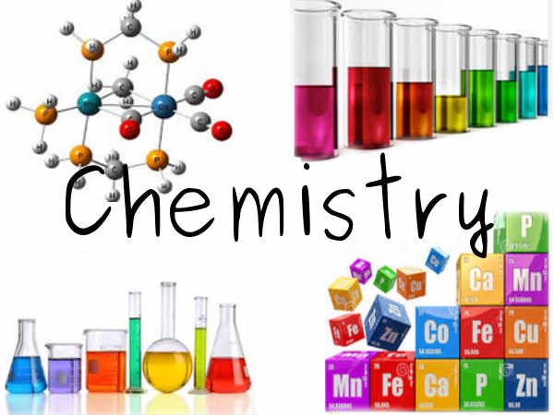
Chemistry 20 Course Outline
Mrs. Gare
Room 122
doris.gare@wrps11.ca

Resources: Nelson Chemistry

Course Content:

Unit 1: The Diversity of Matter and Chemical Bonding Chapter 3
By the end of this unit students will be able to:
- Describe the role of modeling, evidence and theory in explaining and understanding the structure, chemical bonding and properties of ionic and molecular compounds.
Key Concepts:
- chemical bonding - ionic bonding -VESPR theory - hydrogen bonding
- covalent bond - electron dot diagram - electronegativity - Lewis structures
- polarity - valence electron - intra/intermolecular forces

Unit 2: Gases as a Form of Matter Chapter 4
By the end of this unit students will be able to:
- Explain molecular behaviour, using models of the gaseous states of matter.
Key Concepts:
- Celsius and Kelvin temperature scales - Boyle’s and Charles Law - SATP/STP - real and ideal gases - law of combining volumes - absolute zero

Unit 3: Solutions, Acids and Bases
Part A: Solutions Chapter 5
By the end of this unit students will be able to:
- Investigate solutions, describing their physical and chemical properties.
Key Concepts:
- homogeneous mixtures - solubility/dilution - Arrhenius theory

Part B: Acids and Bases Chapter 6
By the end of this unit students will be able to:
- Describe acidic and basic solutions qualitatively and quantitatively.
Key Concepts:
- weak acids and bases - indicator - pH and pOH
- monoprotic/polyprotic acids/bases - strong acids and bases

Unit 4: Stoichiometry Chapters 7 & 8
By the end of this unit students will be able to:
- Explain how balanced equations indicate the quantitative relationships between reactants and products involved in chemical changes.
- Use stoichiometry in quantitative analysis
Key Concepts:
- chemical reaction equations - net ionic equations - spectator ions - precipitation
- limiting and excess reagents - reaction stoichiometry - equivalence point - titration - end point - limiting and excess reagent - reaction stoichiometry

Course Timeline Dates

Science 10 Review 4 days September 4 to 7
Unit 1: The Diversity of Matter and Chemical Bonding 14 days September 10 to 27
Unit 2: Gases as a Form of Matter 13 days October 1 to 19
Unit 3: Solutions, Acids and Bases
Part A: Solutions 13 days October 22 to November 6
Part B: Acids and Bases 13 days November 7 to 28
Unit 4: Stoichiometry 24 days November 29 to January 16
Review 4 days January 17 to 22

Course Evaluation
Class Mark Unit Exams 40%
Quizzes 20 %
Assignments/labs 10 %
Final 30 %

Unit Exams: There will be 5 exams in the course – one at the end of each unit. Each exam will be comprised of multiple choice, numerical response and written response questions. Each exam will be worth the following, as determined by the Alberta Program of Studies.
Unit 1: 20%
Unit 2: 16%
Unit 3: Part A: 16%
Part B: 16%
Unit 4: 32%

Quizzes: There will be numerous quizzes throughout the semester. Quizzes will take a variety of formats and will be composed of multiple choice, numeric response and written response questions.
Assignments: Assignments will be based on course work.
Lab Reports: The labs that you conduct will require either partial or full lab write-ups to be submitted for marks. If you have an unexcused absence on the day of a lab you will be given a mark of “0”. .
*The majority of labs, assignments and quizzes will be weighted equally, as determined by percentages. Teacher discretion may determine that some evaluations have heavier weightings.

Final Exam: Consists of a Part A that is the multiple choice and a numeric response component, and a Part B that is a written response component.

LINKS
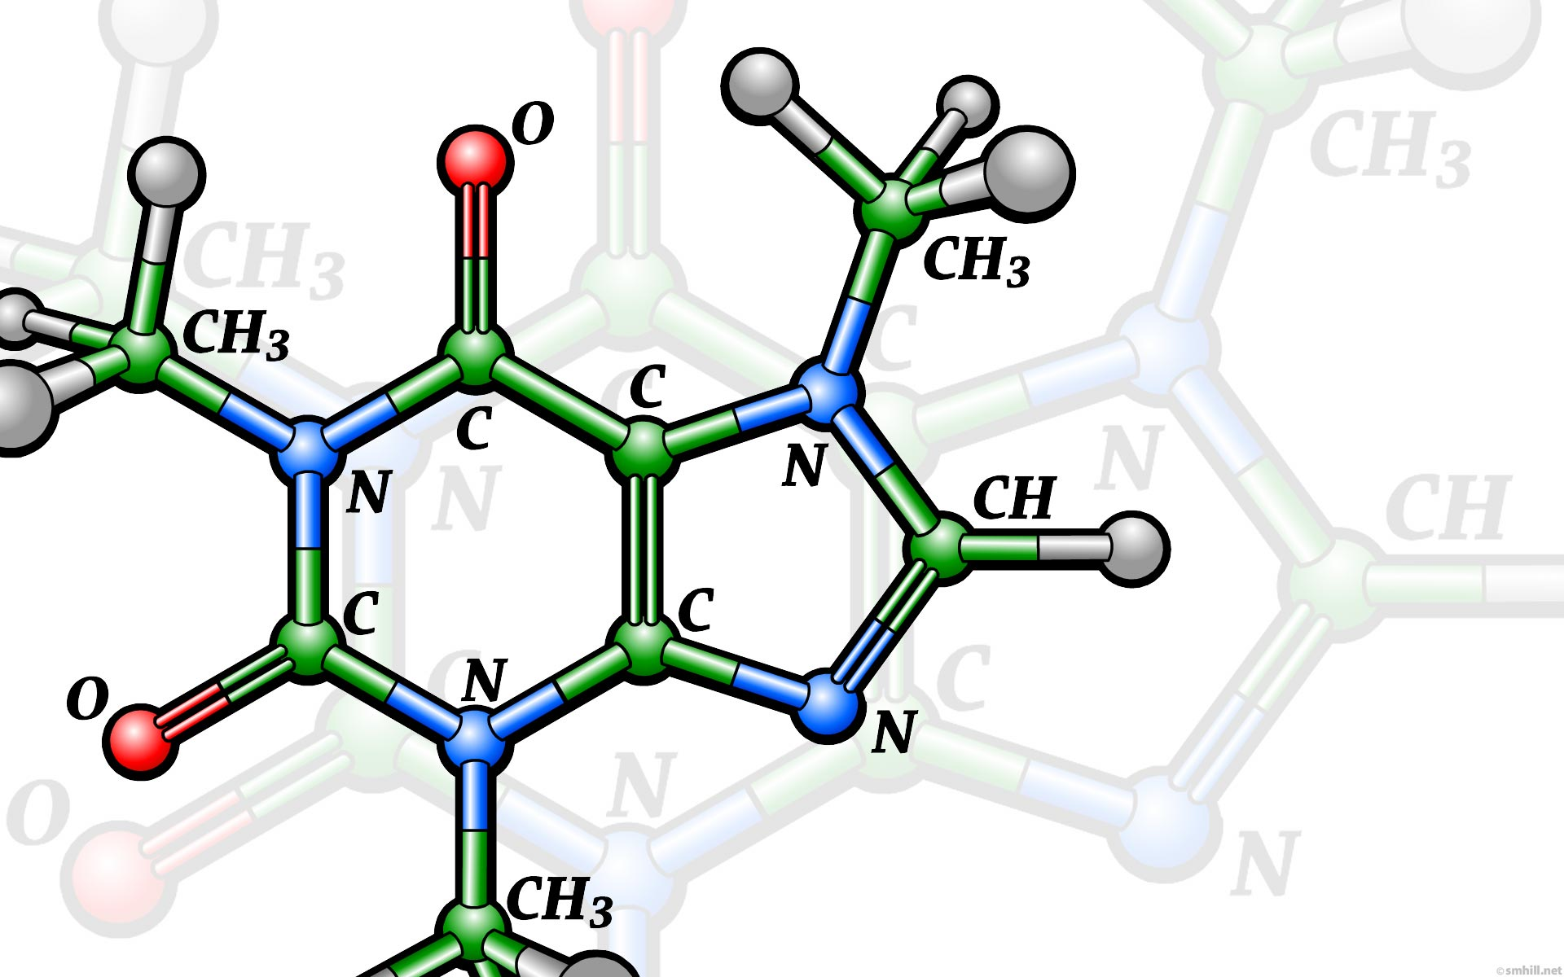
Academic Expectations
https://wetaskiwincomp.ca/students/academic-expectations

